Terraform challenge

1) Create VPC
2) Create Internet gateway
3) Create Custom Route Table
4) Create Subnet
5) Associate subnet with Route Table
6) Create Security Group to allow port 22.80,443
7) Create a network interface with an ip in the subnet that was created in step 4
8) Assign an elastic IP to the network interface created in step 7
9) Create Ubuntu server and install/enable apache2
Lets create main.tf file
Create VPC
A Virtual Private Cloud (VPC) is your isolated network in AWS. It defines the IP range (CIDR block) and acts like your private data center in the cloud.
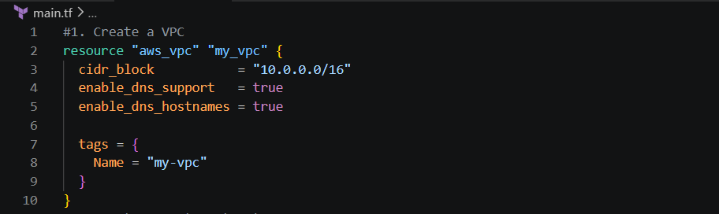
Vpc are created
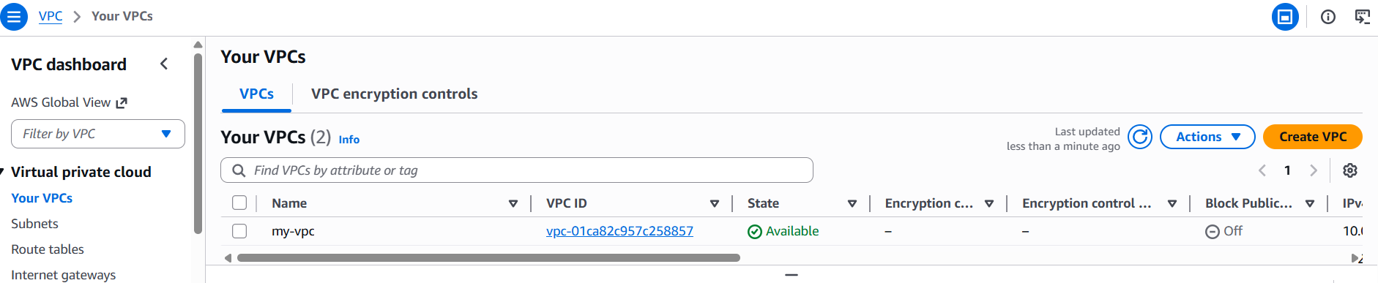
Create Internet Gateway
An Internet Gateway (IGW) connects your VPC to the internet. Without it, resources inside your VPC cannot reach or be reached from the outside world.
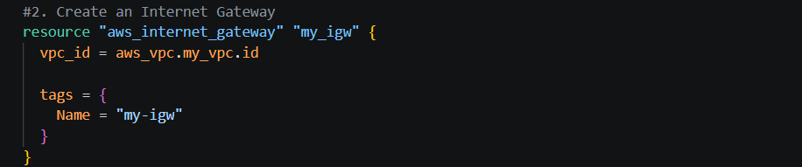
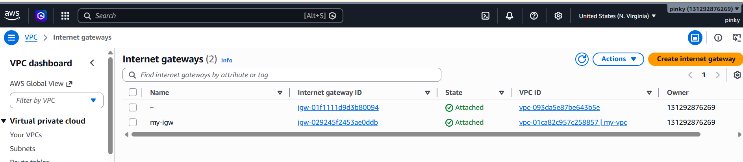
Create Custom Route Table
A Route Table defines how traffic flows. You add a route that sends all non-local traffic (0.0.0.0/0) to the Internet Gateway so your subnet can access the internet.
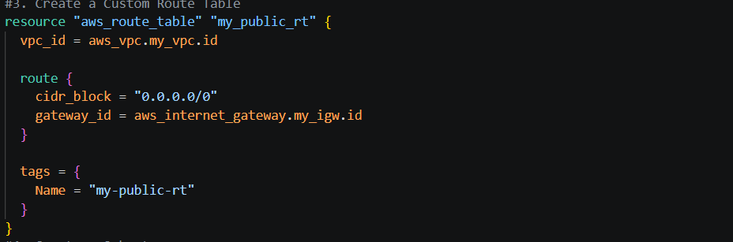
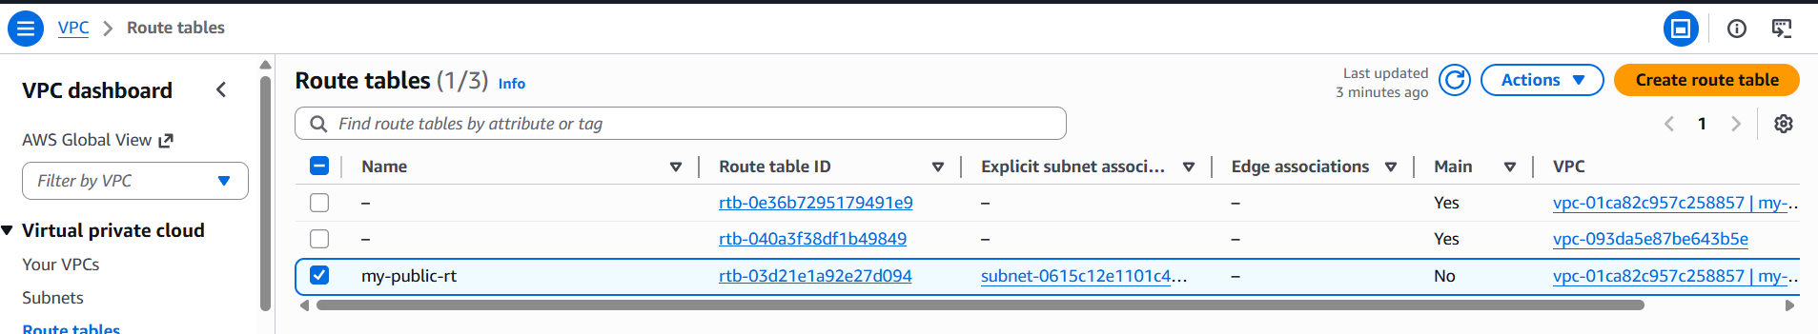
Create Subnet
A Subnet is a smaller network inside your VPC. It divides your VPC’s IP range into segments. You’ll place your EC2 instance inside this subnet.
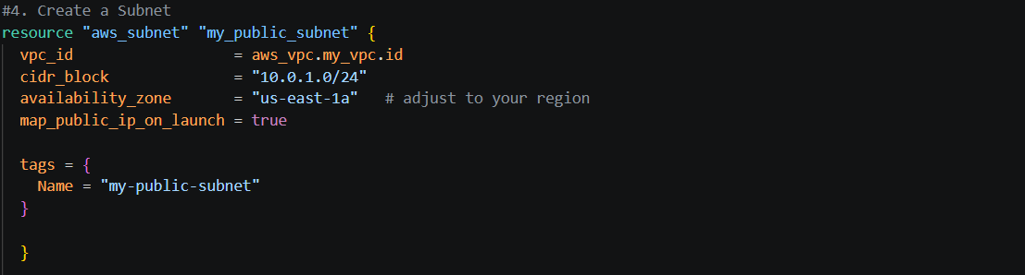
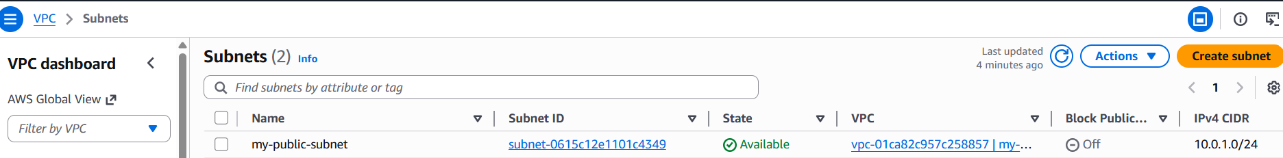
Associate Subnet with Route Table
This step links your subnet to the route table so that resources inside the subnet know how to reach the internet via the IGW.
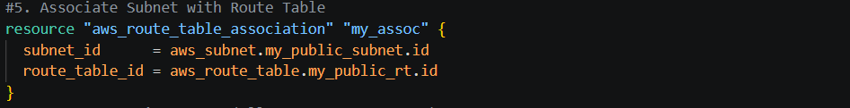
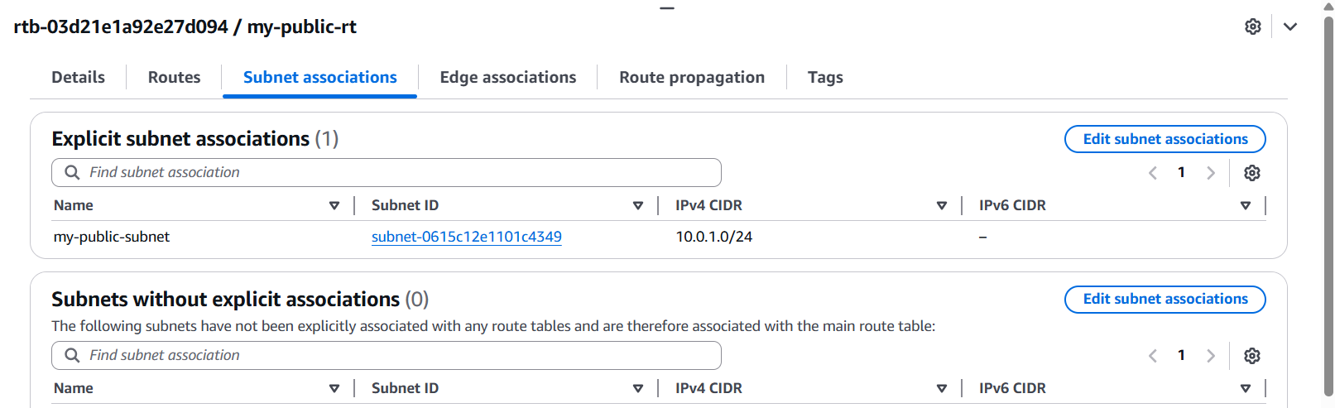
Create Security Group (allow ports 22, 80, 443)
A Security Group is a virtual firewall.
- Port 22 → SSH (remote login)
- Port 80 → HTTP (web traffic)
- Port 443 → HTTPS (secure web traffic) This ensures your server is accessible for management and web hosting.
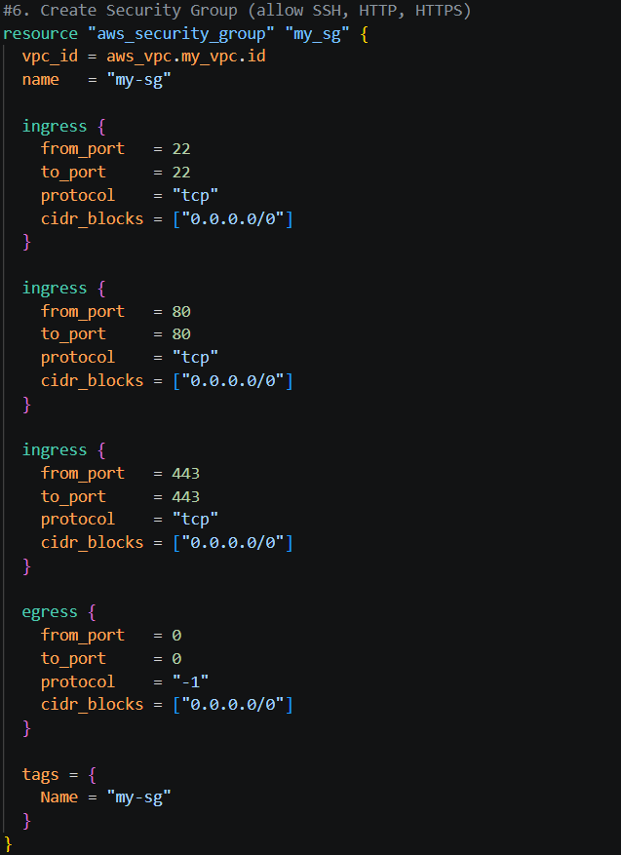
Create Network Interface
A Network Interface (ENI) is like a virtual network card. You assign it an IP inside your subnet and attach the security group. Your EC2 instance will use this ENI to connect.
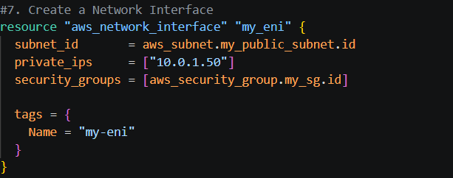
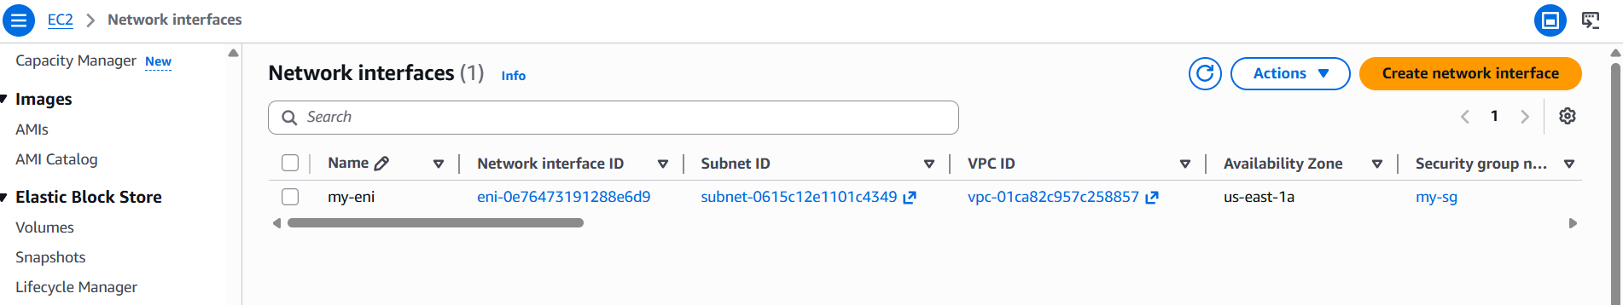
Assign Elastic IP
An Elastic IP (EIP) is a static public IP address. It ensures your server always has the same public IP, even if you restart or replace the instance.
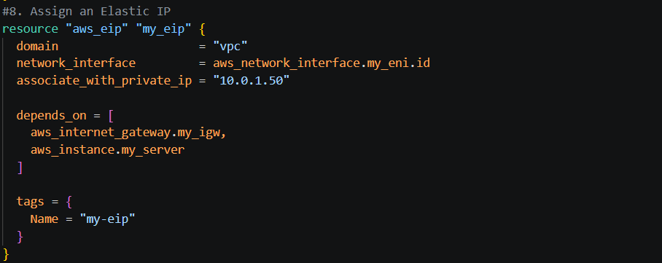
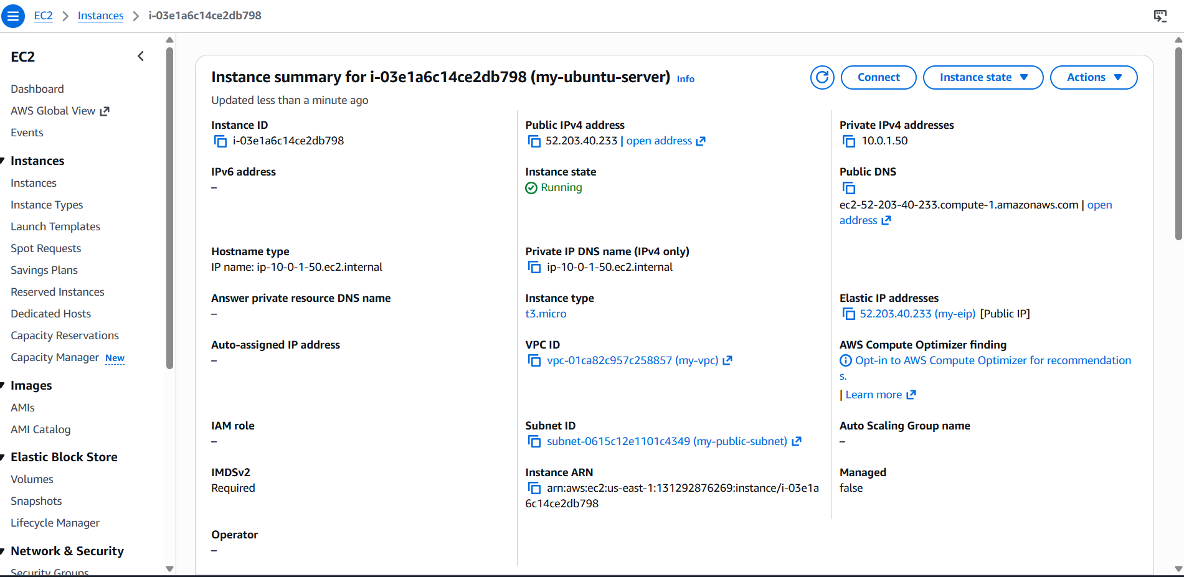
Create Ubuntu Server and Install Apache2
An EC2 instance is your virtual machine. You’ll launch Ubuntu, attach the ENI, and run a user data script to install and enable Apache2. This makes the server a web host, serving content over HTTP/HTTPS.
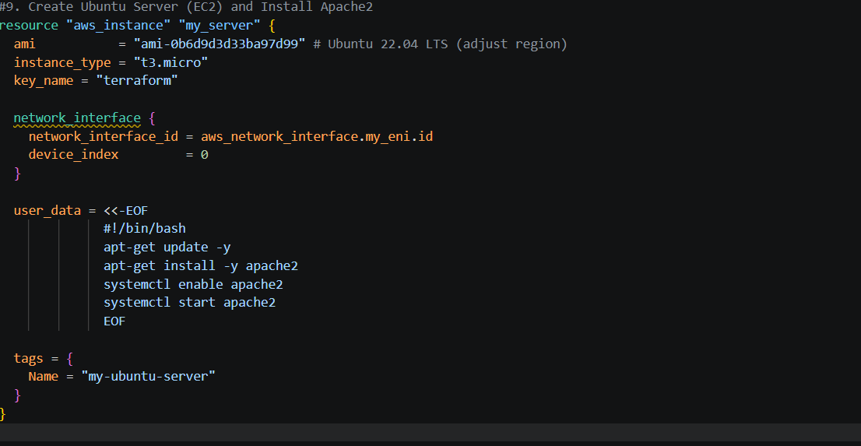
Lets perform
terraform init
terraform plan
terraform apply
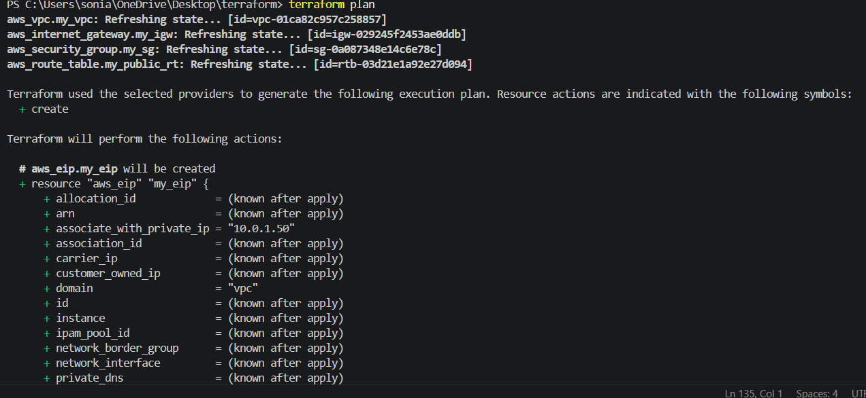
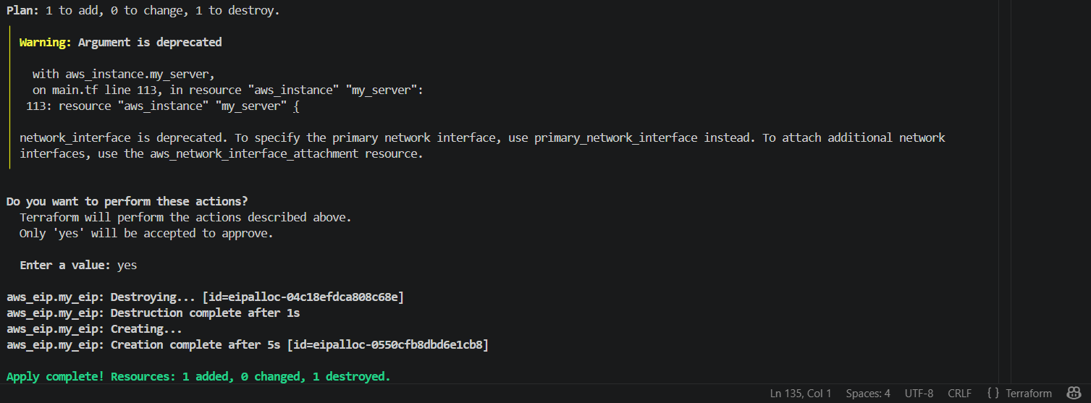
Verify the browser
